Conversational Agents: Capabilities, Sample Proposals, Tools & Data Sources
Capabilities that we wish to develop across all our conversational agent projects:
- LLM Agnostic: Enable seamless integration across models to avoid lock-in and ensure adaptability.
- Conversational Programmability: Transform natural language into executable agent behaviors for dynamic control.
- Knowledge Graph: Provide structured, explainable maps of entities and relationships enriched with a lexical codebook.
- Design Patterns for Connectors: Standardize reusable templates for ingesting and structuring diverse data sources.
- Design Patterns for Prompts: Modularize prompt strategies with headers, examples, and meta-patterns for flexible testing.
- Indexing and Retrieval: Deliver efficient, context-aware access to scalable information stores.
- Multi-Agent Orchestration: Coordinate specialized agents to collaborate, delegate, and solve complex tasks collectively.
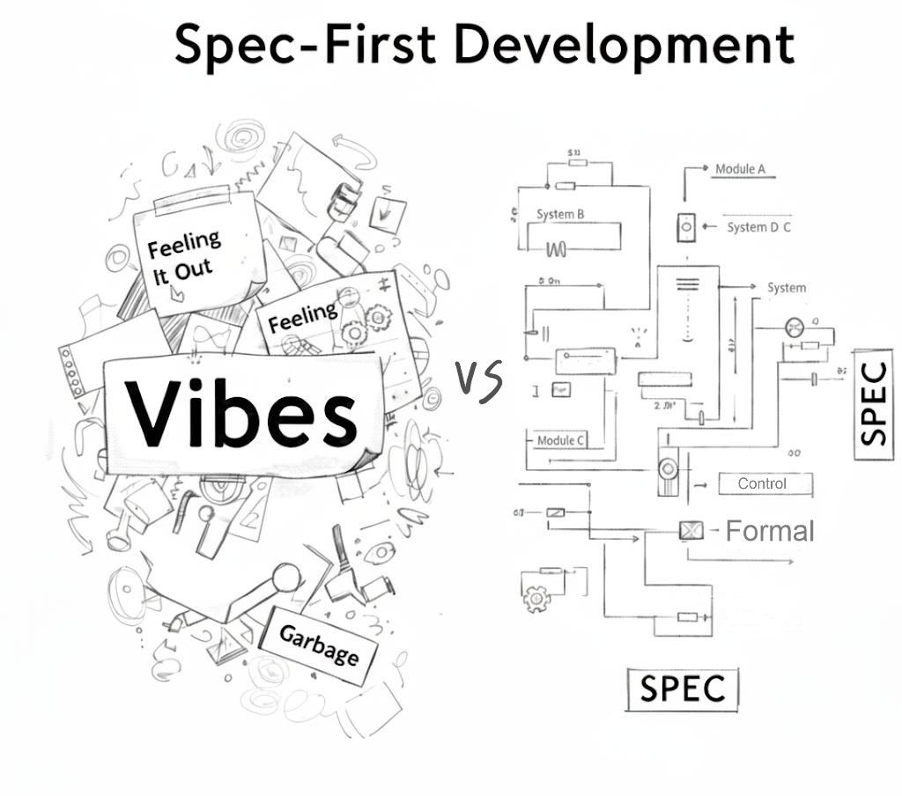
- Persuasive Narrative Programming with Metadata Constraints: A metadata-governed paradigm that structures adaptive, ethical, and verifiable persuasive narratives, transforming threats into explainable levers and shared values through bounded persuasion.
Introduction: Explore a comprehensive 3-hour online course on Agentic Knowledge Graph Construction with Google's ADK here: Agentic Knowledge Graph Construction
Data Collection Tools:
- Selenium – browser automation, good for dynamic sites.
- Playwright (Oxylabs Guide) – modern, scalable, JavaScript-Savvy.
- Browser Use – LLM-powered agentic automation.
Desktop/Laptop LLMs: Here’s a rough “ladder” you can keep in mind for running models locally on a laptop with Ollama. Think of it as tiers—each step-up trades more RAM/compute for better reasoning, coding, and language ability. For details click here.
Quick Ranking (small → big): Phi-3 Mini (3 GB RAM; runs fine on CPU-only laptops) → Mistral 7B ≈ Qwen 7B (6 GB RAM; sweet spot for most laptops; doesn’t demand a GPU, but GPU helps) → Llama 3.1 8B ≈ Gemma 9B (8 GB RAM; runs on higher-end laptops 16–32 GB RAM. GPU acceleration recommended but optional) → Qwen 14B ≈ Gemma 27B ≈ Mixtral (20+ GB RAM; this is the point where a GPU becomes almost mandatory) → Llama 3.1 70B (70 GB+; needs server-grade GPUs (A100/H100 or multi-card setups)—not really “laptop territory.”)
Agentic AI Libraries and Frameworks designed to make agent development feel more like software development, to make it easier for developers to create, deploy, and orchestrate agentic architectures that range from simple tasks to complex workflows.
- LangFlow – Visual builder for LangChain
  - Drag-and-drop prompts, LLMs, tools, memory, and agents; export to Python/JSON or REST API.
  - Rapid prototyping with templates and live debugging; self-hostable with LangChain integrations.
- AutoGen – Ease of use & fast prototyping for interactive, conversational systems
  - Budget-conscious teams: Ollama, Phi-3, LLaMA-2, BLOOM, Falcon
- CrewAI – Structured workflows for teams of agents
  - Ideal for coordinating specialized agents with task dependencies and execution order
  - A lean, fast Python framework built from scratch, independent of LangChain (docs).
- N8n - low-code workflow automation with AI agents
  - 500+ integrations, SOC2 compliance, fast-start templates, and fine-grained LLM cost control.
- LangChain – Linear agent flows
  - Ideal when flow is simple: prompt → model → (optional tool) → return
  - Hugging Face–hosted models (Vicuna-13B, vLLM, BLOOM, OPT, LLaMA, XGen, etc.).
  - Massive community + integrations (vector DBs, tools, providers, tutorials, agents, fine-tuning)
- LangGraph – Code-first multi-agent orchestration
  - For rich control flow you’ll quickly want LangGraph.
- Google ADK – Modular, code-first agent framework
  - Model-agnostic (Gemini-optimized) with rich tools, evals, tracing, and a dev UI/CLI (adk run, adk web); run locally or deploy to Vertex AI.
  - Built for multi-agent orchestration and interoperability (A2A); samples and quickstarts for Python & Java.
AI Powered Knowledge Graph Generators: Transform unstructured data (PDFs, DOCs, TXT, YouTube videos, web pages, etc.) into a structured Knowledge Graph stored in Neo4j using the power of Large Language Models (LLMs).
- LangExtract: https://github.com/google/langextract
- Neo4j: https://github.com/neo4j-labs/llm-graph-builder
  - https://neo4j.com/labs/genai-ecosystem/llm-graph-builder-deployment/
  - https://neo4j.com/blog/knowledge-graph/how-to-build-knowledge-graph/
  - https://neo4j.com/blog/developer/unstructured-text-to-knowledge-graph/
- AI-Knowledge-Graph: https://github.com/robert-mcdermott/ai-knowledge-graph
  - A Tutorial I downloaded from Web Archive
Chat with Your Knowledge Graph: By combining LLM-generated knowledge graphs and graph machine learning, GraphRAG enables us to answer important classes of questions that we cannot attempt with baseline RAG alone
- MS - GraphRAG: Knowledge Graph Interpretation and Search
  - https://github.com/microsoft/graphrag
  - https://microsoft.github.io/graphrag/get_started/
- Datastax - GraphRAG: https://datastax.github.io/graph-rag/
- NeoConverse - GraphRAG: https://neo4j.com/blog/developer/graphrag-and-agentic-architecture-with-neoconverse/
- Graphiti: Real-Time Knowledge Graphs for AI Agents
  - https://github.com/getzep/graphiti
  - https://github.com/commitbyrajat/example-graphiti

Persuasive Narrative Programming with Metadata Constraints
Persuasive Narrative Programming may be understood as a computational paradigm for the systematic design, structuring, and delivery of stories intended to shape audience attitudes, beliefs, and actions. Within this paradigm, narrative is not conceived merely as a rhetorical artifact but as a programmable, adaptive system. Informed by theories of rhetoric, psychology, and narratology, Persuasive Narrative Programming integrates dynamic feedback mechanisms that continuously respond to audience contexts, affective states, and projected outcomes.
Iterative Adaptation and Systems Thinking
At its core, this paradigm recognizes that persuasive efficacy is iterative rather than fixed. Effective narrative design must therefore incorporate continuous cycles of feedback analysis, performance evaluation, and scenario testing—principles aligned with cybernetics and systems theory. Through this lens, narrative arcs become contextually adaptive, ethically grounded, and resilient across diverse media ecologies.
Metadata as Structural Constraints
The computational foundation of this framework is defined by metadata schemas that establish the conditions under which narratives are validated, optimized, and deployed. These schemas impose epistemic thresholds through two key regulatory bounds:
- Lower Bound Schema: Defines the minimal criteria for narrative validity and ethical acceptability, ensuring that outputs avoid disinformation, remain accessible to baseline literacy levels, and achieve logical coherence.
- Upper Bound Schema: Establishes the maximal permissible scope of influence and complexity, thereby preventing overfitting to specific audiences, constraining manipulative excess, and safeguarding transparency in alignment with ethical norms.
Together, these metadata bounds operate as regulatory guardrails, mitigating both under-determination (weak, ineffective persuasion) and over-determination (coercive or manipulative messaging).
Data-Driven Narrative Logic
The epistemic engine of Persuasive Narrative Programming lies in data-driven methodologies that filter informational noise, detect key recurring themes, and accelerate the design of optimized story structures. Crucially, such patterns require disciplined methodologies of inference and model fitting, bound by metadata schemas.
These methods unfold across three interdependent dimensions:
- Functions (Mappings and Transformations): Computational operators that capture shifts and trends within dynamic data streams. Operating within metadata thresholds, they ensure pattern detection is both reliable and bounded in scope.
- Rules with Conditions (Structured Logic): Boolean constraints that validate contextual states, establish boundary conditions, and regulate decision-making. Explicitly disciplined by metadata, they delimit the logical space within which persuasive strategies may operate.
- Agents (Automata): Behavioral models that simulate systemic dynamics. Instantiated as Mealy machines, these agents embody narrative progression across three key phases: Key Recurring Themes and Wedges (Threats/Issues) → Midpoints (Programmable, Explainable Levers) → Common Goods (Shared Values). Metadata constraints here ensure ethical continuity and systemic balance.
Toward a Metadata-Governed Theory of Computational Persuasion
By embedding lower- and upper-bound schemas, Persuasive Narrative Programming becomes a self-regulating system of computational persuasion. These epistemic thresholds guarantee that narratives are contextually valid, ethically bounded, and technically optimized, situating the framework at the intersection of communication theory, computational narratology, and responsible AI design.
Persuasive Narrative Programming is thus not the mere automation of storytelling, but rather the orchestration of bounded persuasion—where metadata functions simultaneously as constraint and guarantor of ethical, effective narrative flow.
Our Foundational Principle
If the programmable explanation underlying an AI’s reasoning process cannot be independently verified, edited, and rigorously debugged—regardless of the specific Large Language Model (LLM) upon which it depends—then all subsequent conclusions and outputs must be treated as fundamentally unreliable.

Capabilities Re-Framed in our Narrative Flow
• Knowledge Graph: A structured, explainable map of entities, relationships, and schemas enriched with a lexical codebook.
Threats-on-Values / Issues (Pain Points):
- Fragmented knowledge → difficult to trust or reuse information
- Black-box reasoning → obscures how facts and logic are connected
- Hallucinations → incorrect outputs erode credibility
Midpoints (Programmable / Explainable Levers):
- Entity–relationship maps → transparent and explainable conceptual connections
- Lexical codebook → unifies terminology and reduces semantic drift
- Schema-based reasoning → provides auditable, reproducible decision logic
Common Goods (Shared Values):
- Security & Well-Being → reliable knowledge reduces risks of error
- Trust & Peace of Mind → transparency fosters user confidence
- Health & Sustainability → structured intelligence supports long-term, reusable insights
- Dignity & Care → equitable access to consistent, unbiased knowledge
In synthesis, the Knowledge Graph, when augmented by a unified lexical codebook, computational functions, and Event–Condition–Action (ECA)–styled rules-as-agents, operates as both regulatory and generative framework. It optimizes narrative structures, enforces explainability, and embeds ethical safeguards. Through this integration, fragmented and opaque reasoning processes are transformed into forms of intelligence that are reliable, reusable, and epistemically trustworthy.

